D. EXECUTING THE PROJECT

Project Design and coding

Design

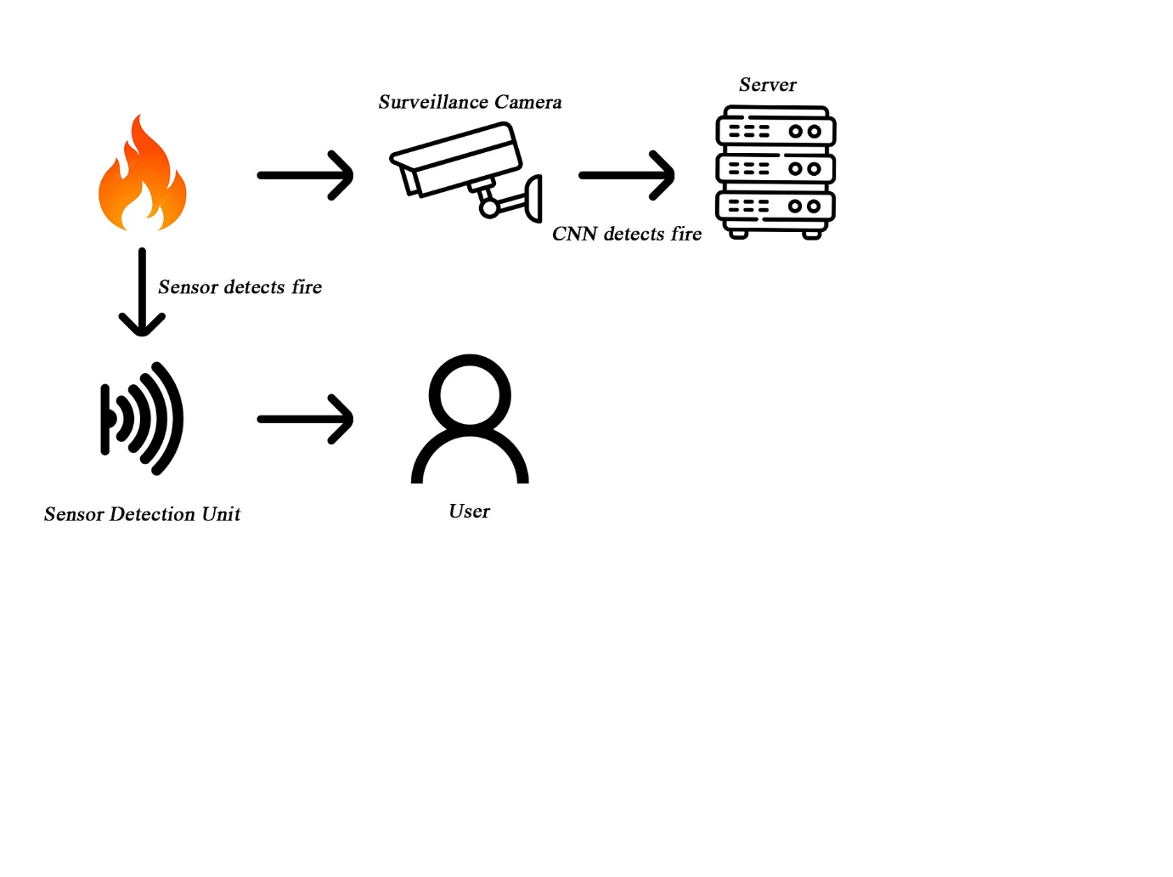

Coding

1. Customized CNN Architecture

1. Inception V3 Model

1. Real Time Testing

Output



